Youth Ministry Update
from Pastor Matt Fowler
mattf@kearneyfirstumc.org; 402-650-9480 | 4.15.24
Parents and Youth:
We have 2 (TWO!) Wednesdays left in our school-year youth ministry season. Our last meeting is April 24.
We have some meaningful events in which to connect and continue growing in our faith throughout the summer (this schedule will come out in another message).
And, we’re also looking toward our fall season, in which we welcome Associate Pastor for youth ministry, Jo Ellen Axthelm.

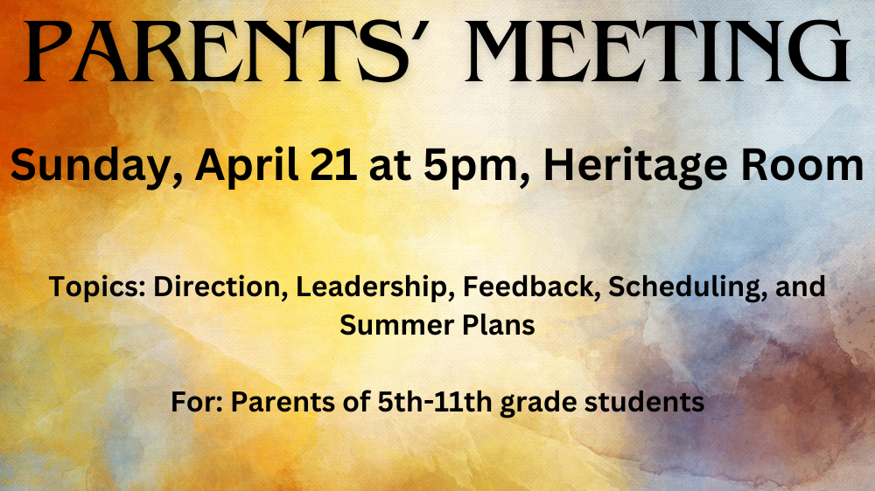
Youth Ministry-Parent Information Meeting
- this Sunday, April 21 at 5pm, Heritage Room
- For parents of 5th-11th Graders
- Hear about the continued focus of youth ministry, the incoming Associate Pastor for youth and caring ministries
- Hear about summer youth ministry plans and offer feedback
- Offer feedback about the Confirmation Preparation process and youth ministry scheduling
If you’re interested but this date doesn’t work, please email or text me and I’ll set up another meeting.
Rend Collective Concert
- Friday, April 26, - 7pm at Kearney E-Free Church (info)
- I’ll be attending; youth and adults are invited to meet there and attend together; I’ll order tickets this week; please register to reserve a ticket.

High School Service & Fellowship Trip
- Dates
- Sign up method?

Important Dates:

- April 19-21 – Confirmation Retreat
- April 28 – Senior Families Meal
- May 5 – Confirmation Sunday
- May 12 – Senior Recognition Sunday (9:30)

Sign Up for Rend Collective Concert

